Assume that you have used Facebook or similar photo sharing applications. Please describe the user story on uploading a photo and two use cases for that task: 1) upload from a file in the local computer; 2) upload with a hyperlink to a web image. You should make the mockup user interface screens (or copy them from the actual running Facebook app/website) to attach in each step in the use case.

Facebook user wants to upload a photo. Two cases that can be used for this is uploading fro a local computer and using a hyperlink to a web image.

Mockup user interface screens?

User Story: As a Facebook user, I want to upload photos to share with my friends and family on my profile.

Use Case 1: Upload from a file in the local computer

1. Go to create and click on post.

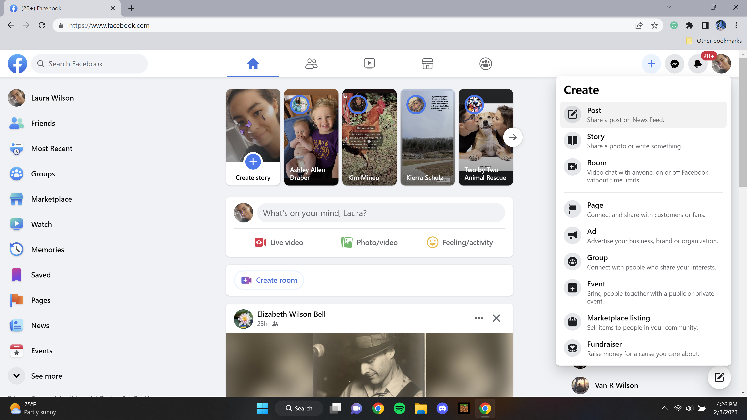

1. Choose the privacy settings for the photo (e.g. Public, Friends, Only Me).

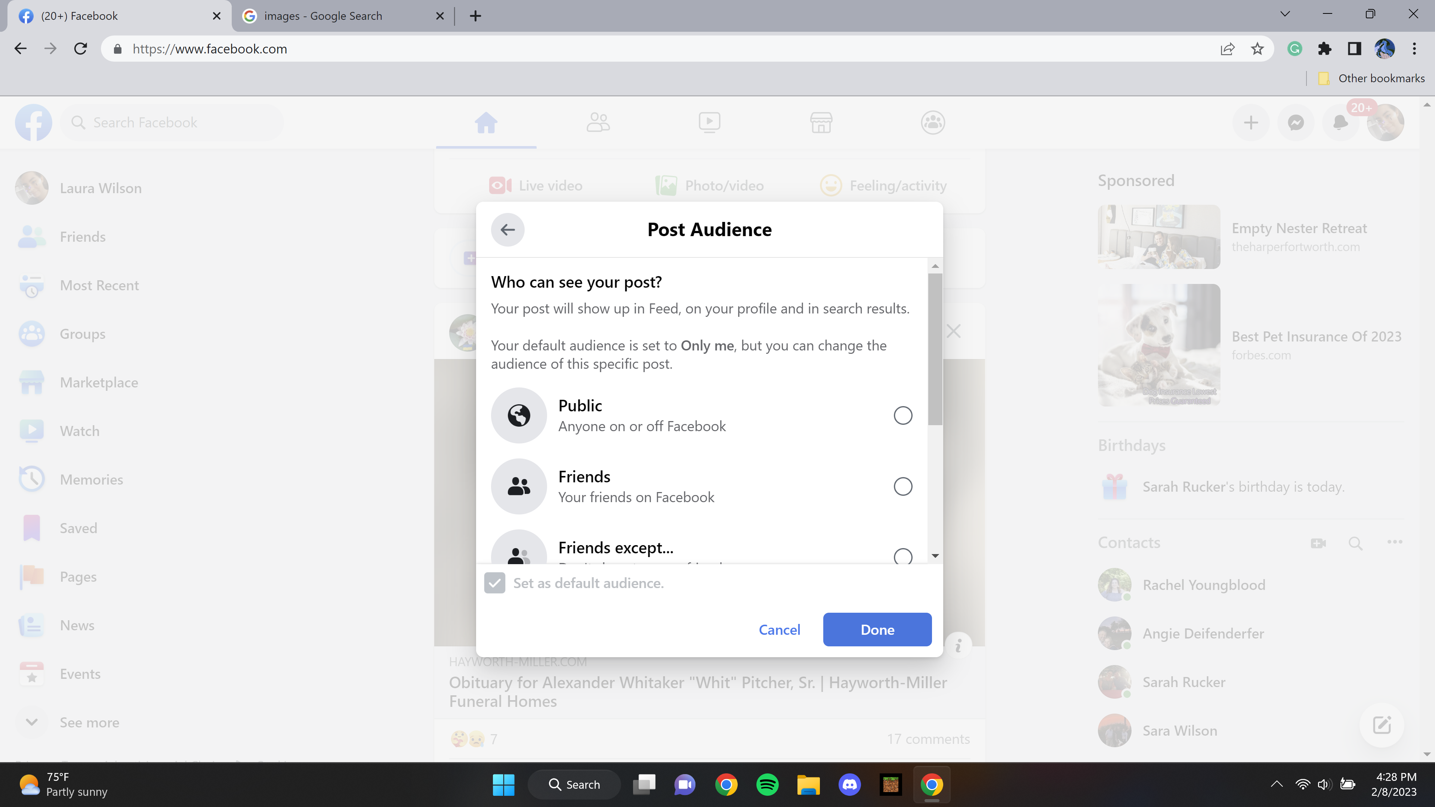

1. Click on the "Add Photo/Video" button on the Facebook profile page.

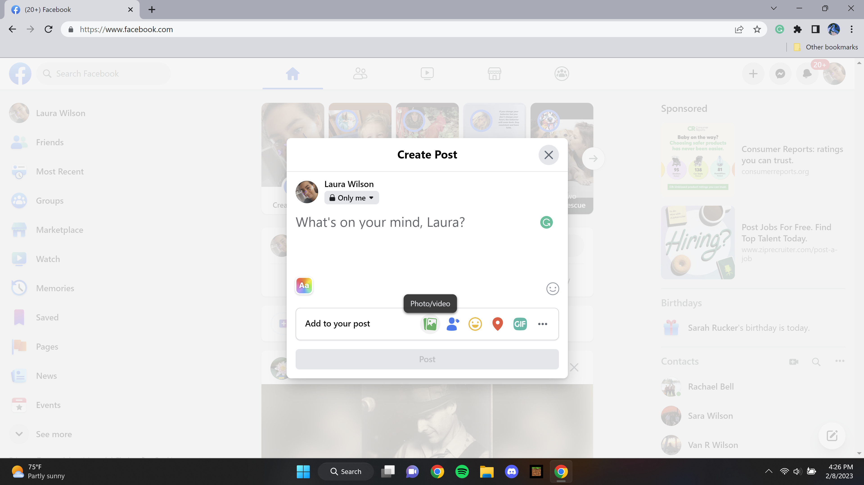

1. A file explorer dialog box opens.

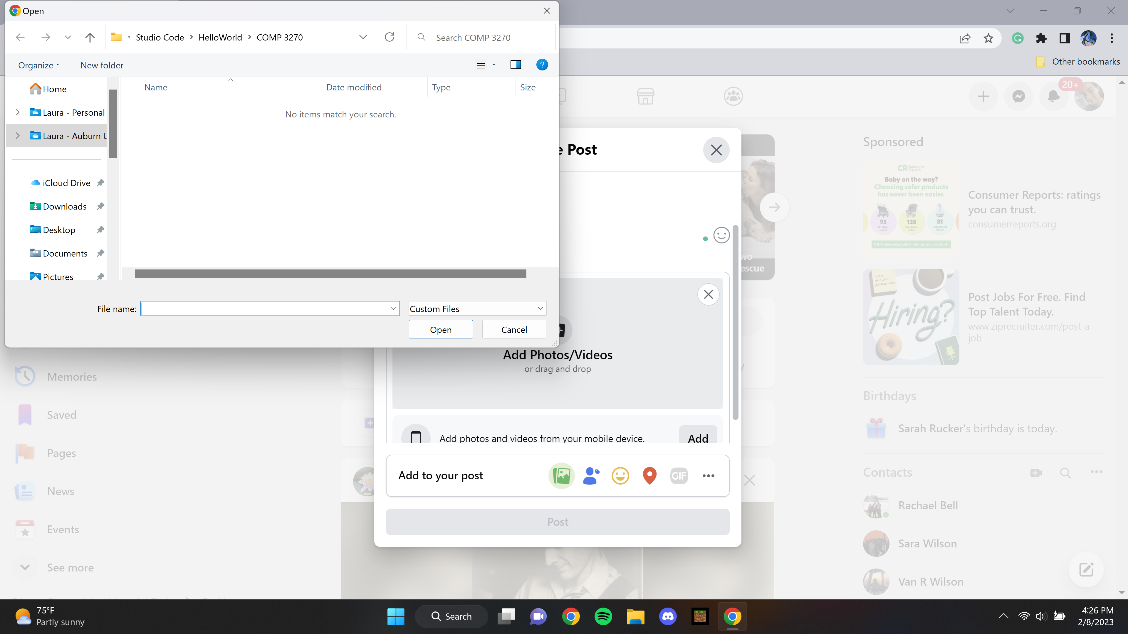

1. Choose the photo file from the local computer. Click on the "Open" button.

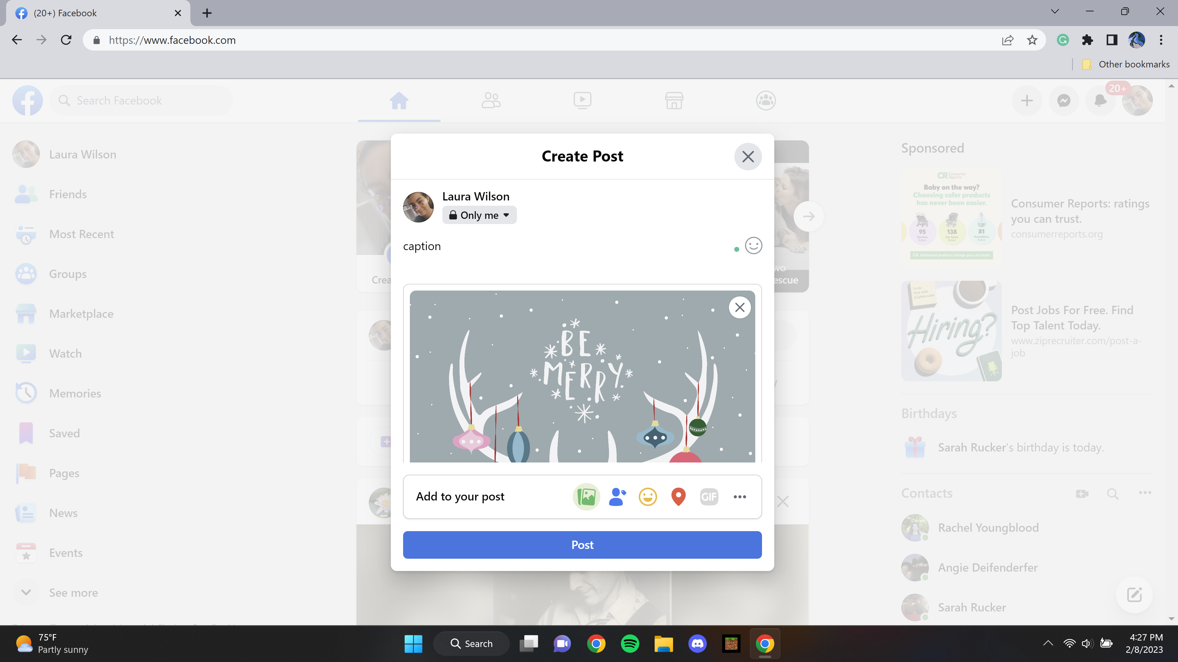

1. The photo is displayed in a preview window.

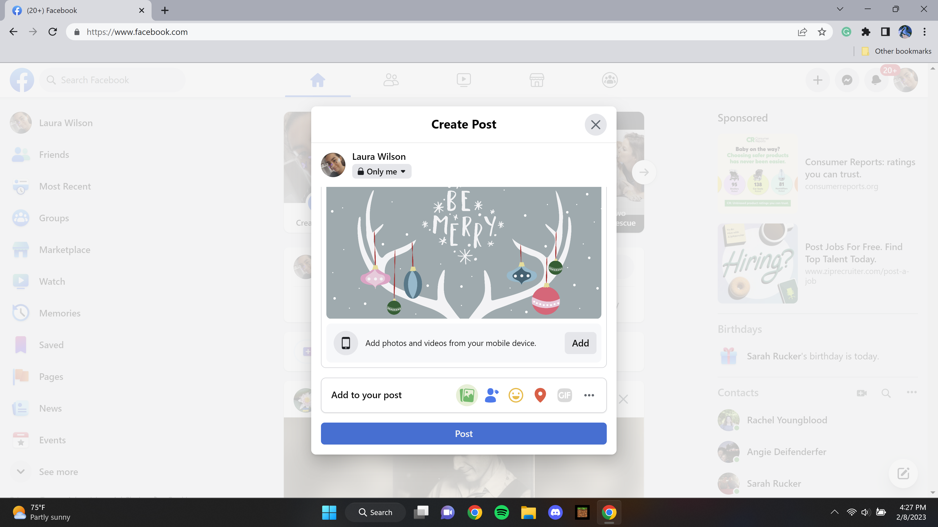

1. Enter a caption for the photo (optional).

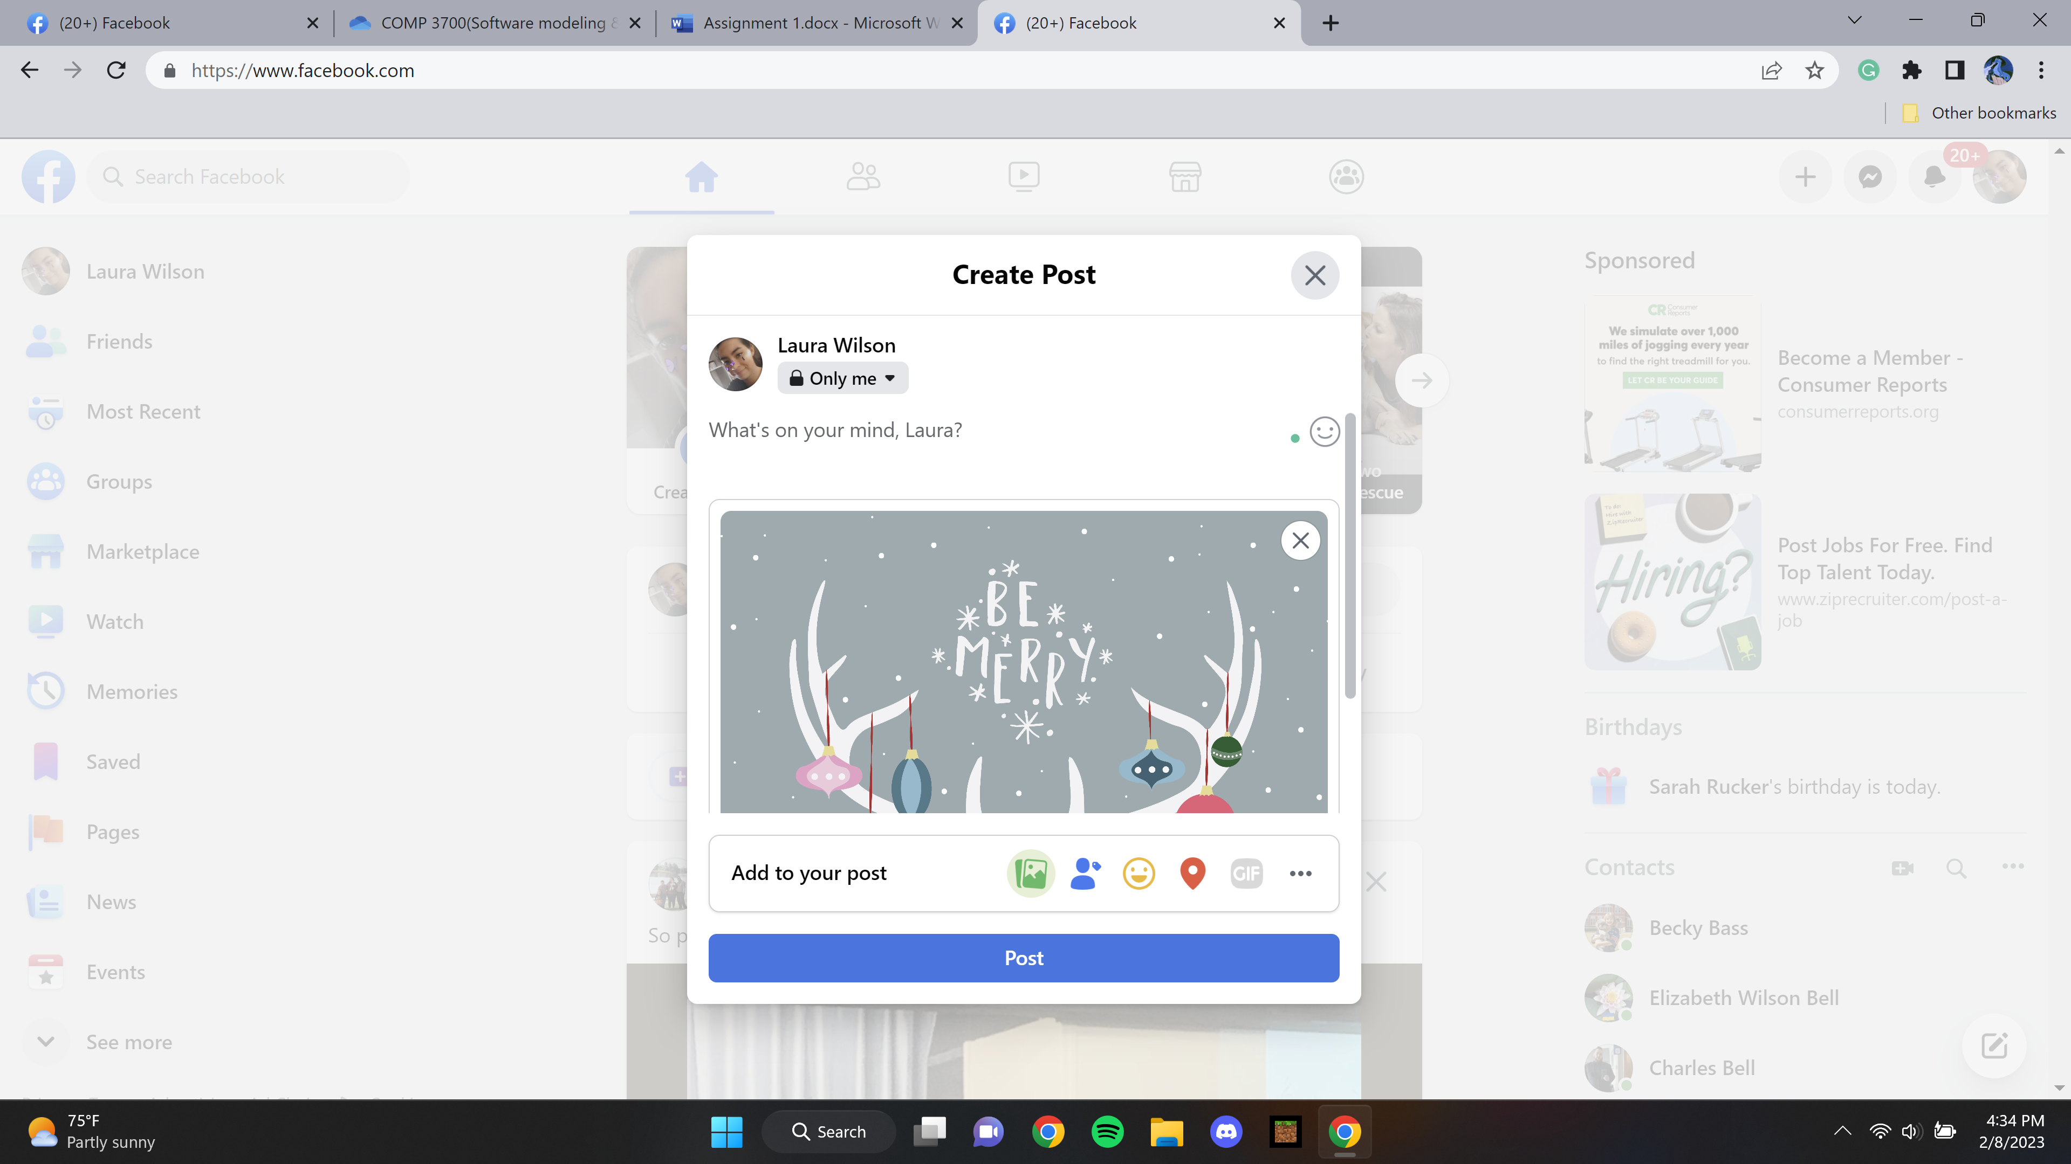

1. Click on the "Post" button.

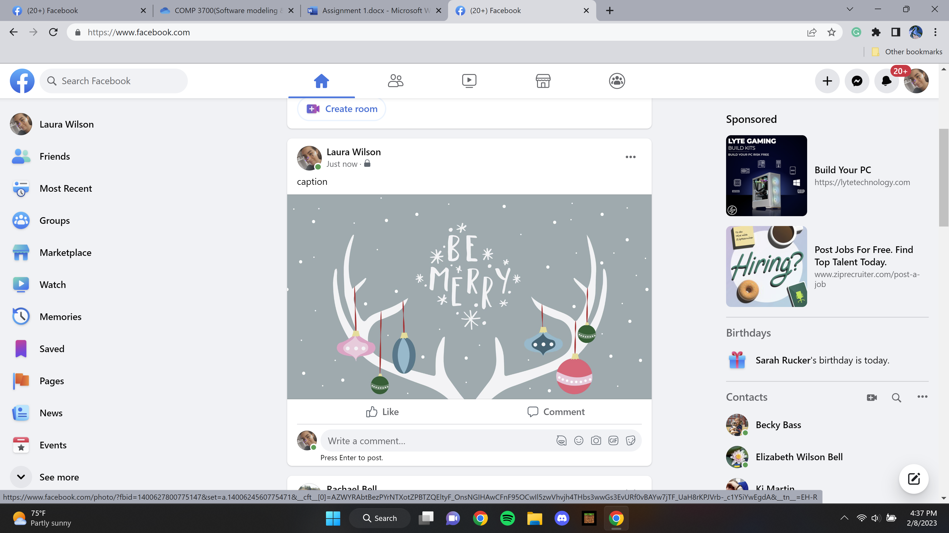

1. The photo is uploaded to Facebook and is now visible on the user's profile page.

Use Case 2: Upload with a hyperlink to a web image

1. Click on the "Add Photo/Video" button on the Facebook profile page



1. Enter the URL of the web image in the text field

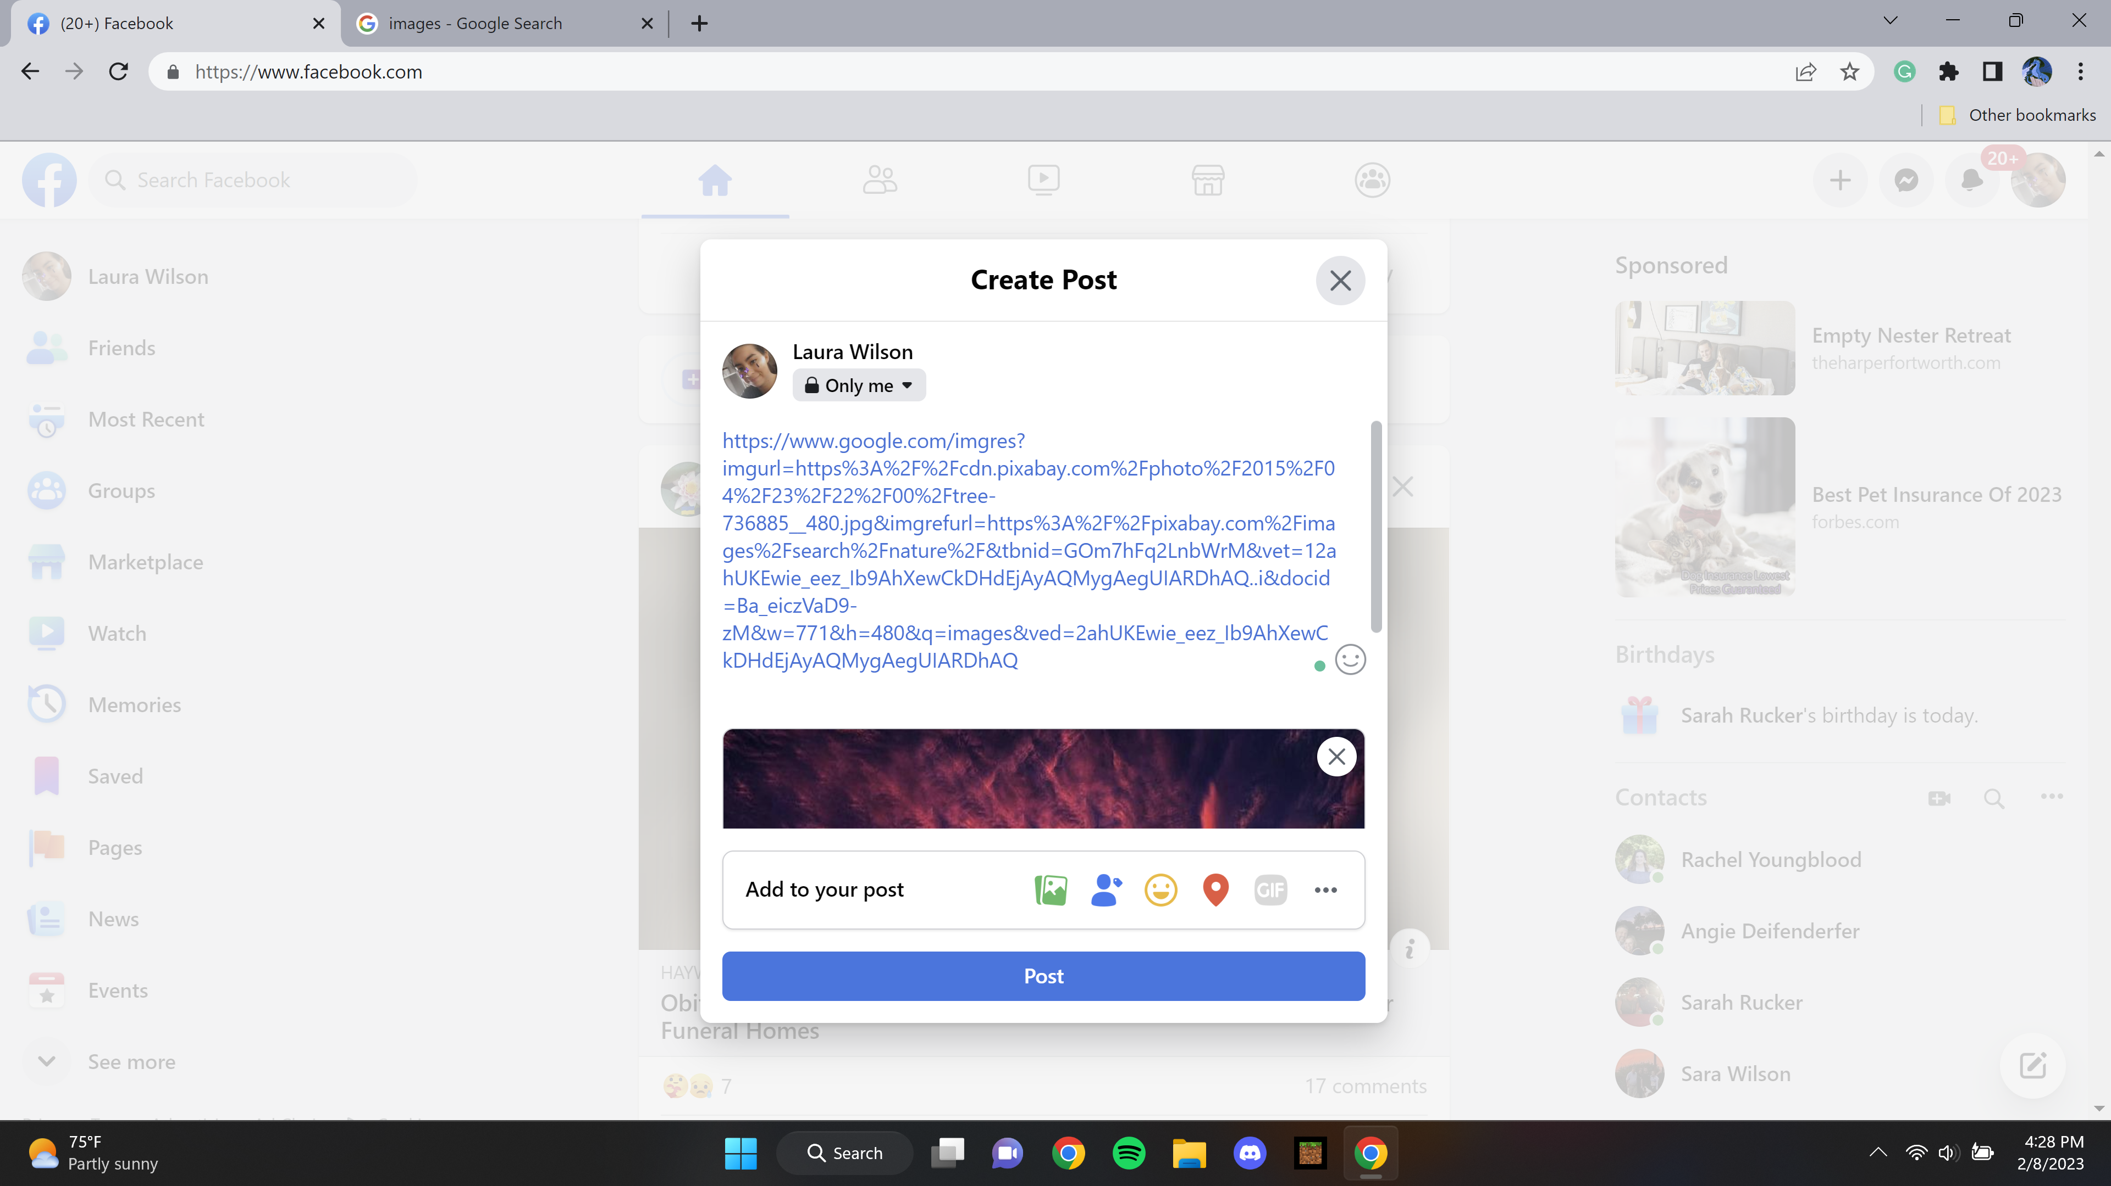

1. Enter a caption for the photo (optional).

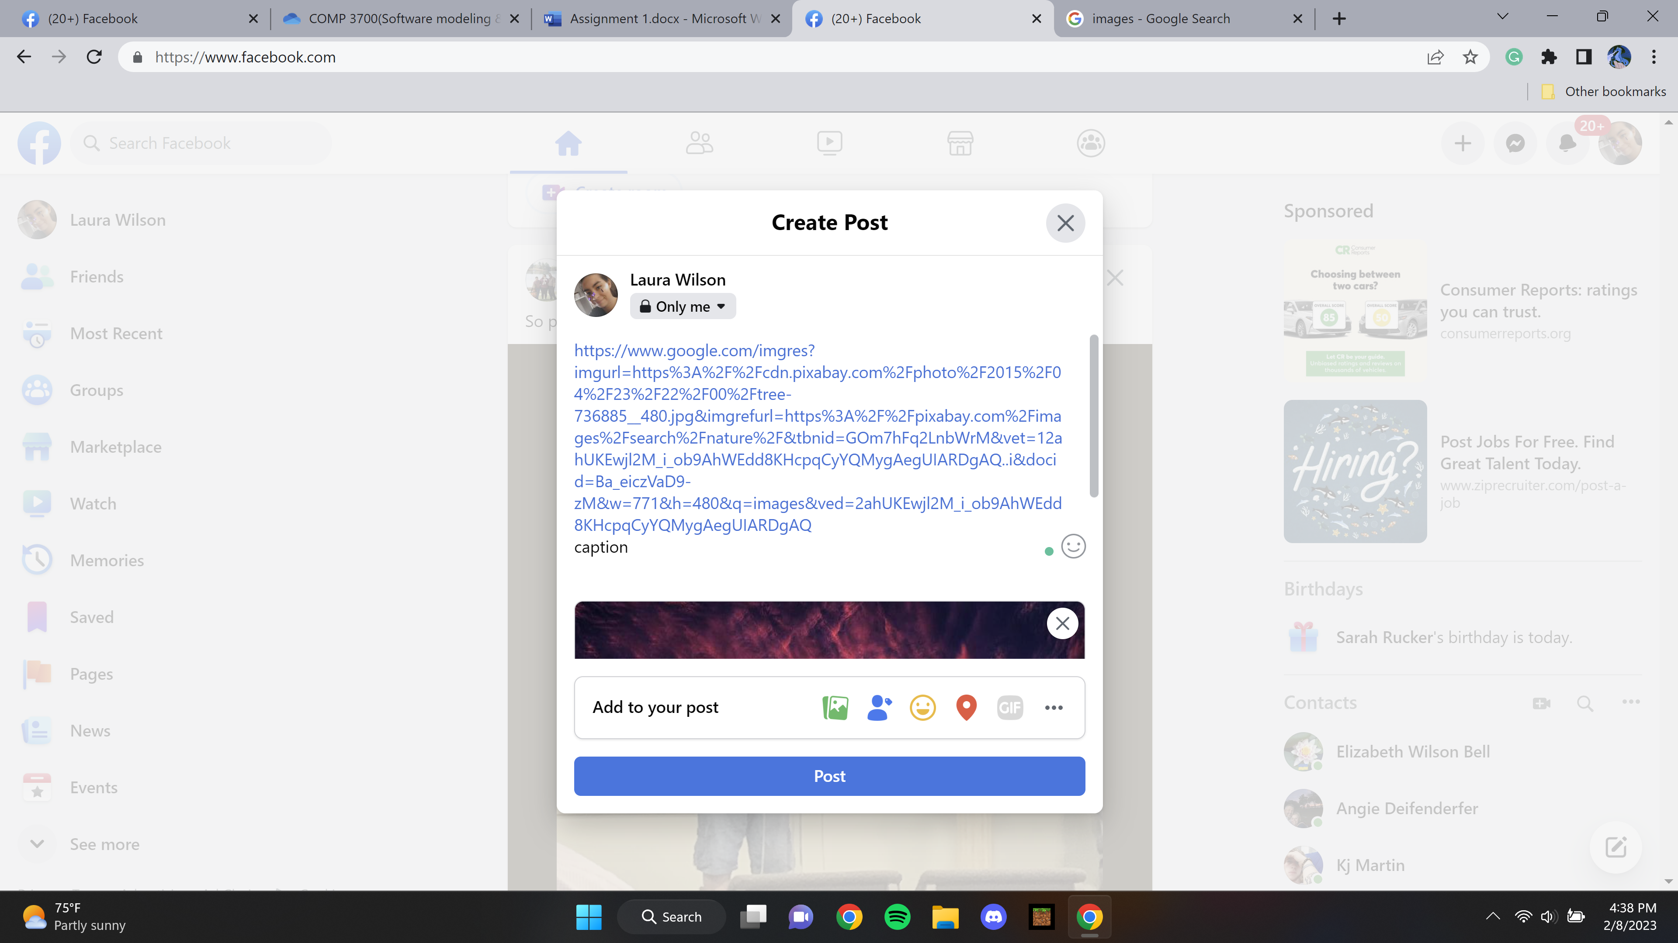

1. Choose the privacy settings for the photo (e.g. Public, Friends, Only Me).



1. Click on the "Post" button.

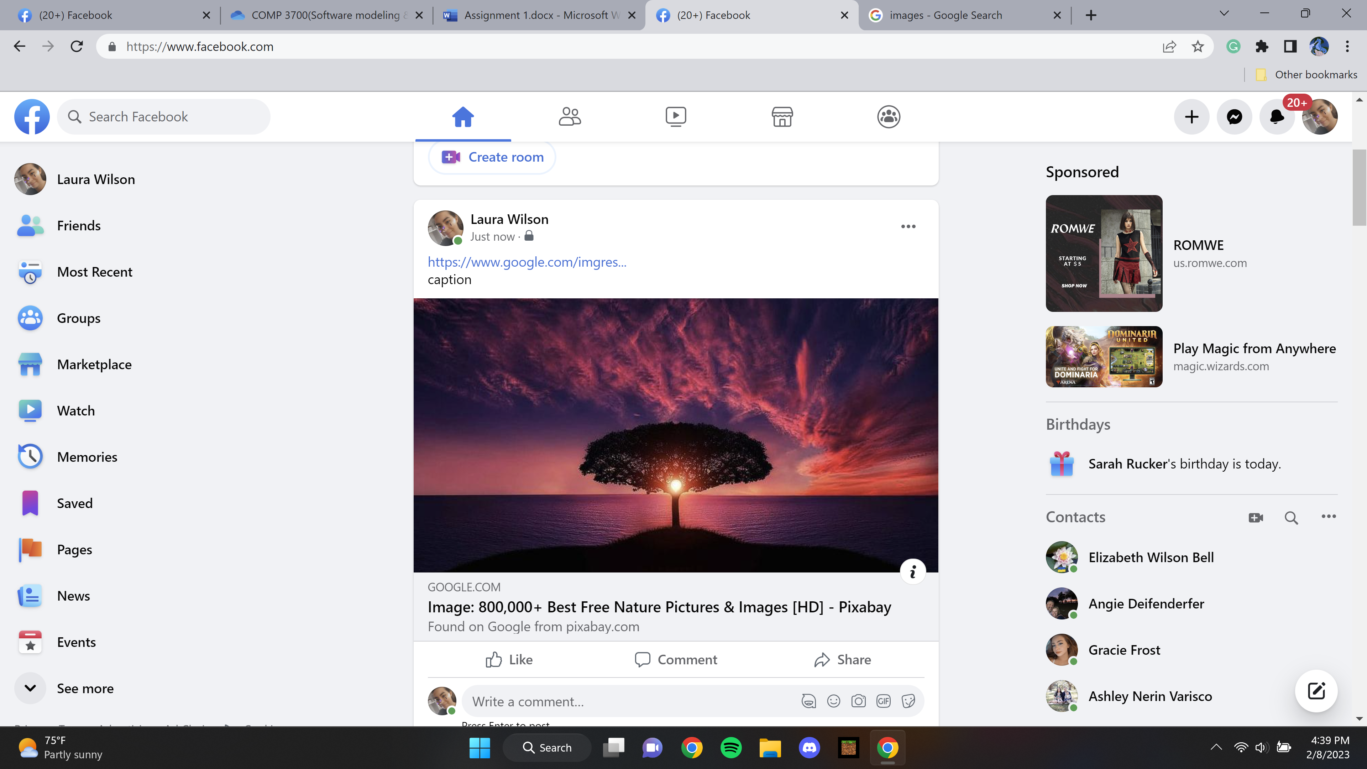

1. The photo is uploaded to Facebook and is now visible on the user's profile page.